Take Apart a Computer Workshop

Disassembling a desktop PC is relatively simple, depending upon what degree of disassembly you intend to do. Most of the basic components are modular and easily removed. However it is important that you be organized about it. This will help to keep you from losing parts, and also in making the reassembly easier. You should plan to do this in a clean, uncluttered space.

Things You'll Need
- A set of screwdrivers ( phillips)
- A small plastic box suitable for holding screws (or some other container)
- Your phone camera
- A laptop with an Internet connection

Step 1
Open the case. This works differently on different computers. Some have a latch that opens, allowing the side panel of the case to simply be slid away. On other cases, you must unscrew several screws. The primary goal is to remove the side panel opposite the motherboard. The motherboard is the large rectangular circuit board into which most of the other components are connected.

Step 2
Take several digital photos of the inside of the computer. These will serve as reference for reassembly.

Step 3
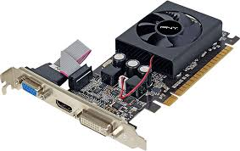
Remove any video cards that are attached in to PCI, PCI Express or AGP slots. These cards are physically plugged into slots and are attached perpendicularly to the motherboard. In some cases a small screw must be removed before you can pull out the card. In other cases, there may be a single latch that holds all of the cards in place. Here’s an example of what a video card may look like after it is taken out:
(Note: The video card may not have a fan on tip or look *exactly* like this picture.)
Raise your hand to get checked off! ______

Step 4
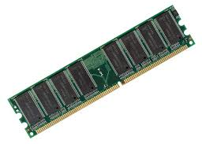
Remove the RAM memory sticks from the DIMM slots. These slots typically have a plastic latch on each side that must be snapped open before the memory sticks can be pulled out. It usually works better to pull the memory sticks out one side at a time. Here’s an example of what a RAM stick might look like:

Raise your hand to get checked off! ______
Step 5
Disconnect the cables from the hard drive(s) and from the DVD drive. Each drive will have two cables. Note carefully, or photograph exactly how they are connected. Red cables are called SATA cables. Grey cables are usually IDE cables. Black cables are power cables.

Step 6
Locate the place where each drive (hard drive, cdrom, floppy??? drive) is screwed into the chassis of the computer case. Take photos, if you need to, in order to remember where the screws are positioned. Remove the screws and slide out the drives. Be careful not to let the drives fall onto the motherboard, as they are heavy and could damage the circuitry.
Raise your hand to get checked off! ______

Step 7
Disconnect the power supply cable from the motherboard. Support the power supply with one hand while carefully unscrewing it from the chassis. Once all the screws are removed, gently lift the power supply away. Do not attempt to disassemble the power supply.

Do not remove the heat sink from the CPU. The heat sink will look like this. | 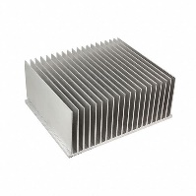
Raise your hand to get checked off! ______

Step 8
Put the whole thing back together, in reverse order. Weee! Test your computer at one of the testing stations by plugging it into power, monitor, and keyboard. Hopefully it boots…

Raise your hand to get checked off! ______

